Trek
Documentation

Documentation Plan for IMU-Based Gait Monitoring Device
All the files, code source, reports and documentation (if available) can be found on github:
https://github.com/Meloc3D/Real-Time-Monitoring-Of-Musculoskeletal-Health

Useful links:
https://docs.arduino.cc/tutorials/nicla-sense-me/cheat-sheet/#sensor-ids

1. Project Overview
- Introduction
PROJECT SUMMARY

The team was tasked with creating a wearable bilateral musculoskeletal monitoring system that delivers real-time data. Given such a broad task, the team had to find a societal problem that needed to be addressed. After extensive research the group found that musculoskeletal diseases affect many people in society and these diseases can often be detected earlier in their progressions through gait imbalances. Currently, the medical field may collect short-term gait data but they do not collect long-term data on patients due to cost and availability. Additionally, the short-term data is usually not useful since it does not show long-term patterns. The team decided that this would be the problem they would seek to solve.

Through the creation of a stride-length monitoring device, the team hopes to help physicians detect musculoskeletal diseases earlier in their progression. Stride-length is a form of gait measurement and thus it is a sufficient way to detect disease. This device will be wearable and measure the stride length of the left and right legs respectively and report it to the user. The ability to measure the stride-length is possible through the use of IMU’s. The user interface of the device will be further developed by another group in the future.

 | MISSION 1 | MISSION 2
STATEMENT | Create a wearable monitoring device that measures stride-length. | Create a wearable device able to measure and compare step duration of both sides of the body over time.
GOALS | - The data collected can be easily read by the user using his personal device. The device reports the stride length of the left and right side of the body, respectively.  - The device uses an IMU device and uses machine learning.  - The data from this device can be processed with machine learning to compare the stride lengths of the left and right side of the body over time for disease detection. | - The device can collect data all day long.  - The device uses Machine Learning to detect the different phases of the walk recorded by an IMU and determine the duration of the step.  - The device can be connected to a smartphone in order to send the data to a practitioner.
SCOPE | - The device will not interpret the data for the user.  - The device will not necessarily be comfortable for the user.  - The device will not be ready for sale at the completion of the project.  - The device will not have to be 100% accurate on the stride length, an accuracy of 70% would be enough for this project. | - The group will not create the user interface/software used on the phone in order to use the data.  - The group will make a prototype, therefore it won’t have to be a fully functional product  - The data from the sensor will not be directly operated but first processed using machine learning in order to recognize motion.
- Key Deliverables
  - Prototypes: you can find all the prototypes and 3D prints in the box
  - Source code.
  - Documentation.

2. System Architecture
- High-Level System Design
  - Overview of the system components.
Components :
- Nicla Sense ME
- SD Card Reader
- Protective charger
- Battery Li-ion
- Switch

Block diagram :

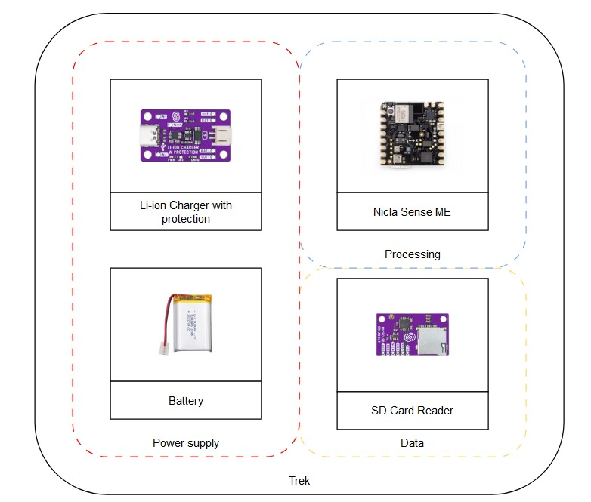
Figure 1 : Block diagram of Trek
- Hardware
  - IMU sensor :
We chose the Nicla sense me because it appeared as a compact, all-in-one sensor with all the feature we needed (bluetooth connectivity, IMU, AI capability)
  - Micro SD card reader:
We chose this SD card reader because it was the only one available for micro SD. Caution: this module needs to be powered with 5V, to power it with 3.7V (battery) it is required to solder the “JP2” jumper on the board in order to bypass the voltage regulator. https://www.digikey.no/en/products/detail/soldered-electronics/333050/21720453
  - Charging/protecting charger: https://elkim.no/produkt/1a-usb-lithium-tp4056-batterilader-battery-charging-module-with-protection/
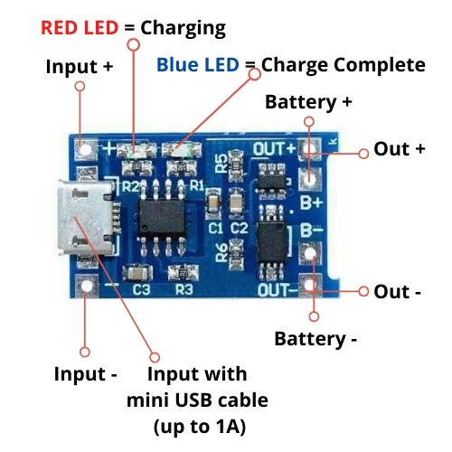
Board size: approx. 26 * 17mm
Input voltage: 5V
Charging cut-off voltage: 4.2V ± 1%
Maximum charge current: 1000mA
Battery over discharge protection voltage: 2.5V
Battery overcurrent protection current: 3A
Instructions:
1. Test current ammeter can only be connected in series at the 5V input of the charging board.
2. Charging current is best battery capacity of 0.37C, is 0.37 times the capacity, such as 1000mAH battery charge current 400 is enough. Too fast to charge the effect of fast, red finished the battery voltage out on the more.
3. The charging connection wire can not be too long. So that the connection resistance is large. Too thin words out of the battery voltage out of the more.
4. Good connection with the battery is good. Or rushed out of the battery voltage out of the more.
5. If the 5V input voltage is high, such as 5.2 or even 5.5, will cause the charging current less than 1000mA, which is normal. High voltage chip heat will automatically reduce the charge current, not to burn the chip. Chip in the work of about 60 degrees heat is normal. After all, the charging current is large.
6. Input reverse does not affect the chip, but the output (battery side) will burn back the chip.

SPECIFICATIONS:
Charge Controller | TP4056 / TC4056
Protection IC | DW01A
Charge/Discharge Control MOSFET | FS8205A
Charge Method | Constant-Current/Constant-Voltage (CC/CV)
Input Supply Voltage | 4.5~6.0 V
Constant Charge Current | 1 A  Configurable with Rprog resistor (R3, see diagrams and TP4056 / TC4056 datasheet)
Charge Complete (Float) Voltage | 4.2 V ±1.5%
Overcharge Protection
Overcharge Detection Voltage | 4.3 V ±50 mV
Overcharge Release Voltage | 4.1 V ±50 mV
Over-Discharge Protection
Over-Discharge Detection Voltage | 2.4 V ±100 mV
Over-Discharge Release Voltage | 3.0 V ±100 mV
Overcurrent Protection
Overcurrent Protection Threshold | 3 A
Overcurrent Cutout Delay | 10~20 ms
Short-Circuit Cutout Delay | 5~50 µs
Trickle Charge (Battery Reconditioning)
Trickle Charge Threshold Voltage | 2.9 V ±0.1 V
Trickle Charge Current | 130 mA ±10 mA
Dimensions
Length | 28 mm (~1.103″)
Diameter | 17 mm (~0.669″)
Weight | 1.6 g (0.057 oz)

- Software
  - Data acquisition and processing software.
  - Gait analysis algorithms.
  - User interface or dashboard (if applicable).
The user interface is out of scope for the part of the project with leaded, we only used excel sheets or matlab for processing purposes

3. Development Details
- Hardware Development
  - Assembly details, schematics, and PCB design (if applicable).
Electronic wiring :
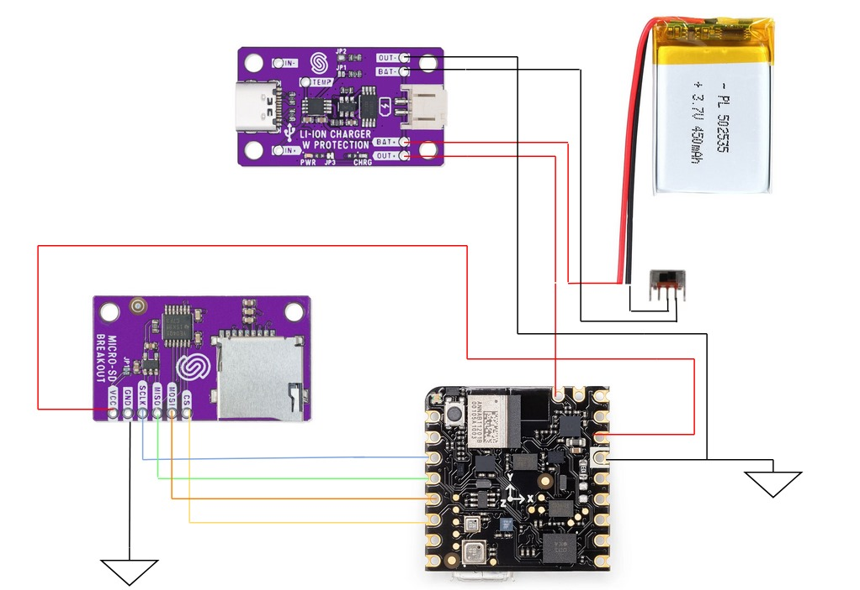

Figure 2 : Electronic wiring

Consumption Part

Theoretical part :

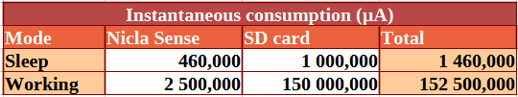

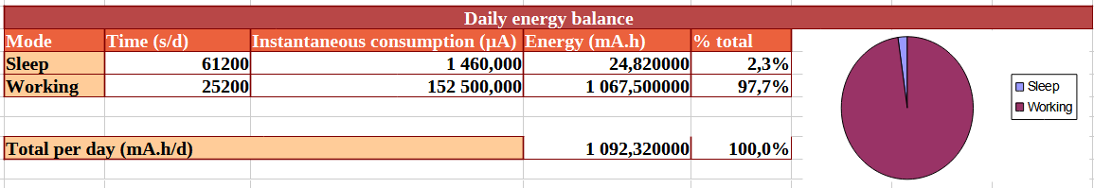
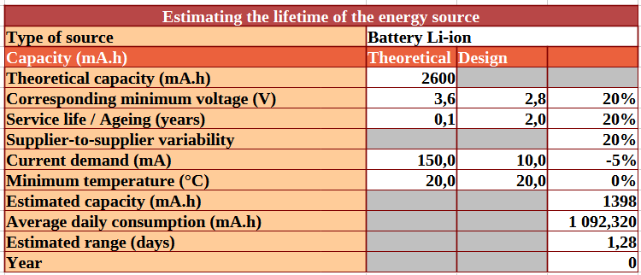

Practical Part :

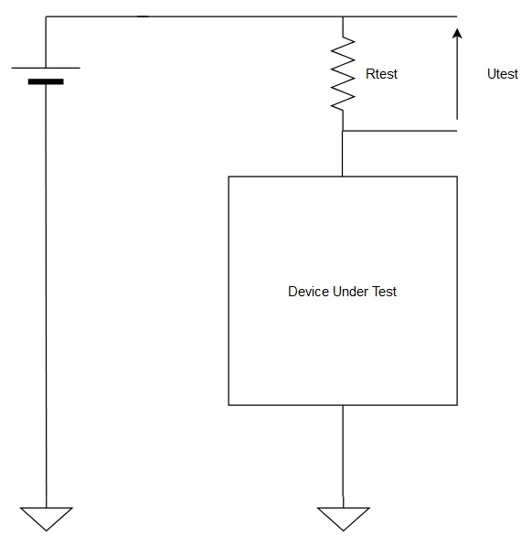

Measuring circuit to determine consumption current. We use the Ohm’s Law to calculate the current.

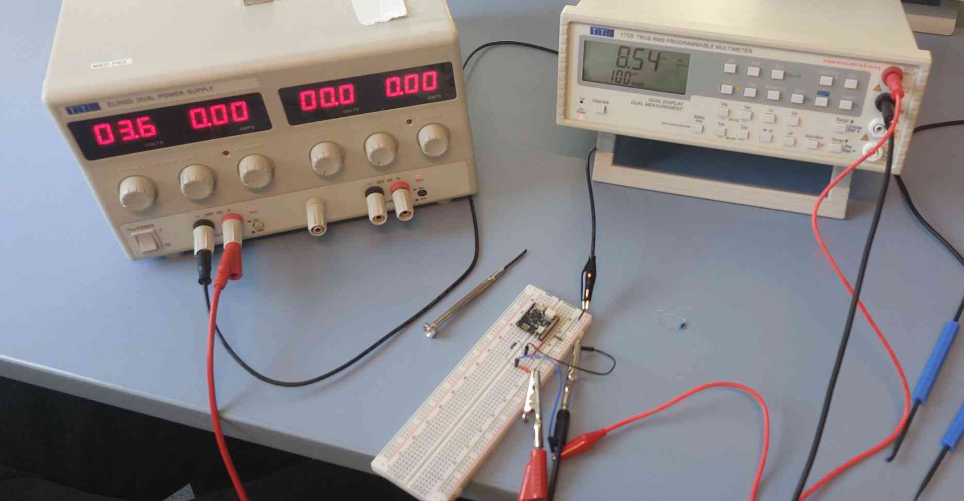

The voltage Utest is equal to 90 mV and Rtest is equal to 10 Ohms. The current is equal to 9 mA.

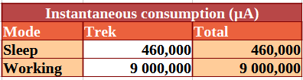
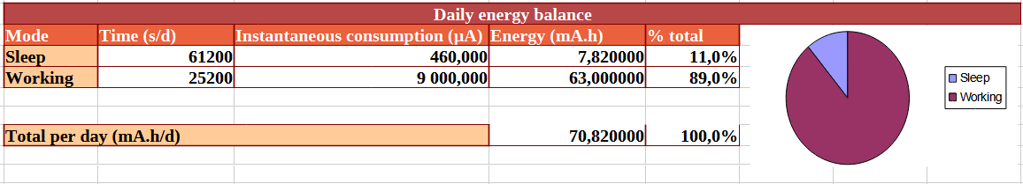
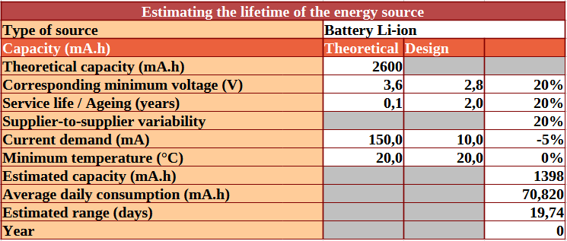

The device can be used for up to 19 days.

- Firmware
  - The device uses data processed by the Bosh BSXX integrated firmware. The list of virtual sensor can be found on the arduino documentation.
- Software
  - All our codes versions for trek are on Github, you can see a quick description of what it does at the beginning of each file
  - For the Matlab scrip, we based it on this project: https://github.com/xioTechnologies/Gait-Tracking-With-x-IMU/tree/master

5. Usage Instructions
- Setup Guide
  - Instructions for assembling or powering the device are depicted on the demo video (link available on github).
  - Calibration of the Bosh BSX software is described in their documentation (copy attached to Github/Components documentation).
- Maintenance
  - Please consider upgrading the BHY2 firmare on the board befor using it (BHY2 example code)

6. Future Recommendations
- Improvement Areas
  - User Interface: Create Website and App
    - Flexible access
    - Easy to read for users
  - Establish Bluetooth connection between
    - Between two sensors for synchronized timestamps
    - Between sensor and personal device to export data
  - Machine learning capability for motion recognition

Use of identical SD cards for consistent write speeds !
  - AI Diagnostic
    - Data would be sorted and interpreted on the board. Currently the data is sorted and processed once it is uploaded to the computer.
.Smaller product
  - Lessen power consumption via AI to better control sleep mode
  - Smaller battery
  - Custom PCB board
- Next Steps
  - Additional testing needed.
  - Possible user feedback collection for iterative design.

8. Contact and Handover
- Team Contact Information
  - Please contact:
killian.renou7@gmail.com (general engineering)
matrewhe@mtu.edu (medical engineering)
abel.didouh@edu.esiee.fr (electrical engineering)
Weidnerjulius@gmail.com (economical engineering)
m.ronja@gmx.de (design)
- Handover Notes
  - Key things the next group should focus on immediately:
Beware of the SD card latency, it can cause different outcomes and generate acceleration blind spots.
  - Known limitations or bugs to address: One of the devices sometimes refused to receive new code during the last days of the project. It might come from the arduino, please note the black tape that is placed on the defective arduino when you receive the Trek box.
  - Please contact us if you have any questions

